9.2D

COS10009

Introduction to programming

**Thanh Minh**

**Student ID: 103809048**

Flow Explanation document

Swinburne University of Technology

I will write up a lot of code so for people who will view my code for the custom program, they can understand quickly and will know the flow of my program. Furthermore, when I work in a company, I also need to comment to explain the code so that if anyone going to fix the code, they will know exactly where to fix otherwise they have to work the program all over again because they don’t understand the code.

1. **Starting page game**

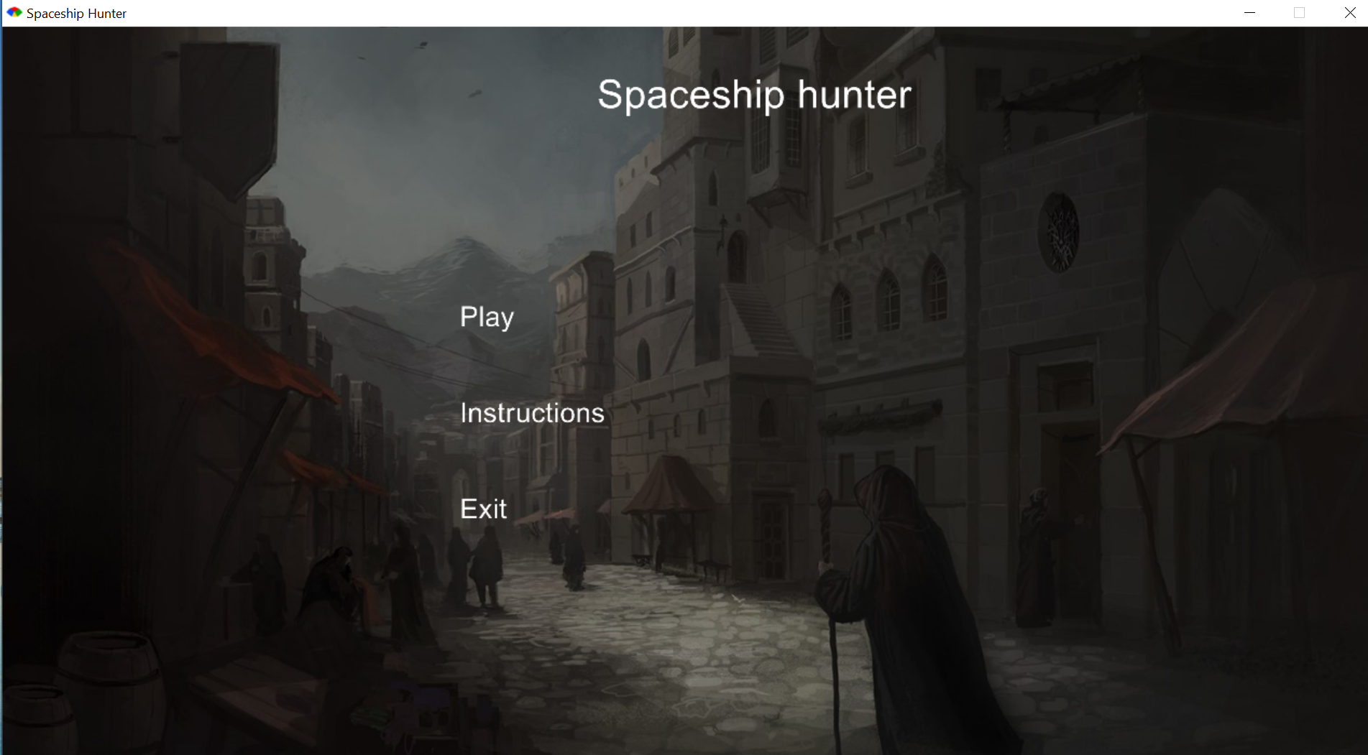

Figure 1: the entry page

This is the entry page of my game and there will be 3 options to choose. The user can both use the mouse or the keyboard up and down in order to move to the choice they want. When the current option is Play, and the user press the keyboard up, the error sound will play or when the current option is Exit, if the user press the keyboard down, the program will also play the error sound.

For the first option, the user will be directed to the choosing ship page.

For the second option, the user will be directed to the choosing ship page.

For the third option, the program will be closed immediately

1. **Instructions page**

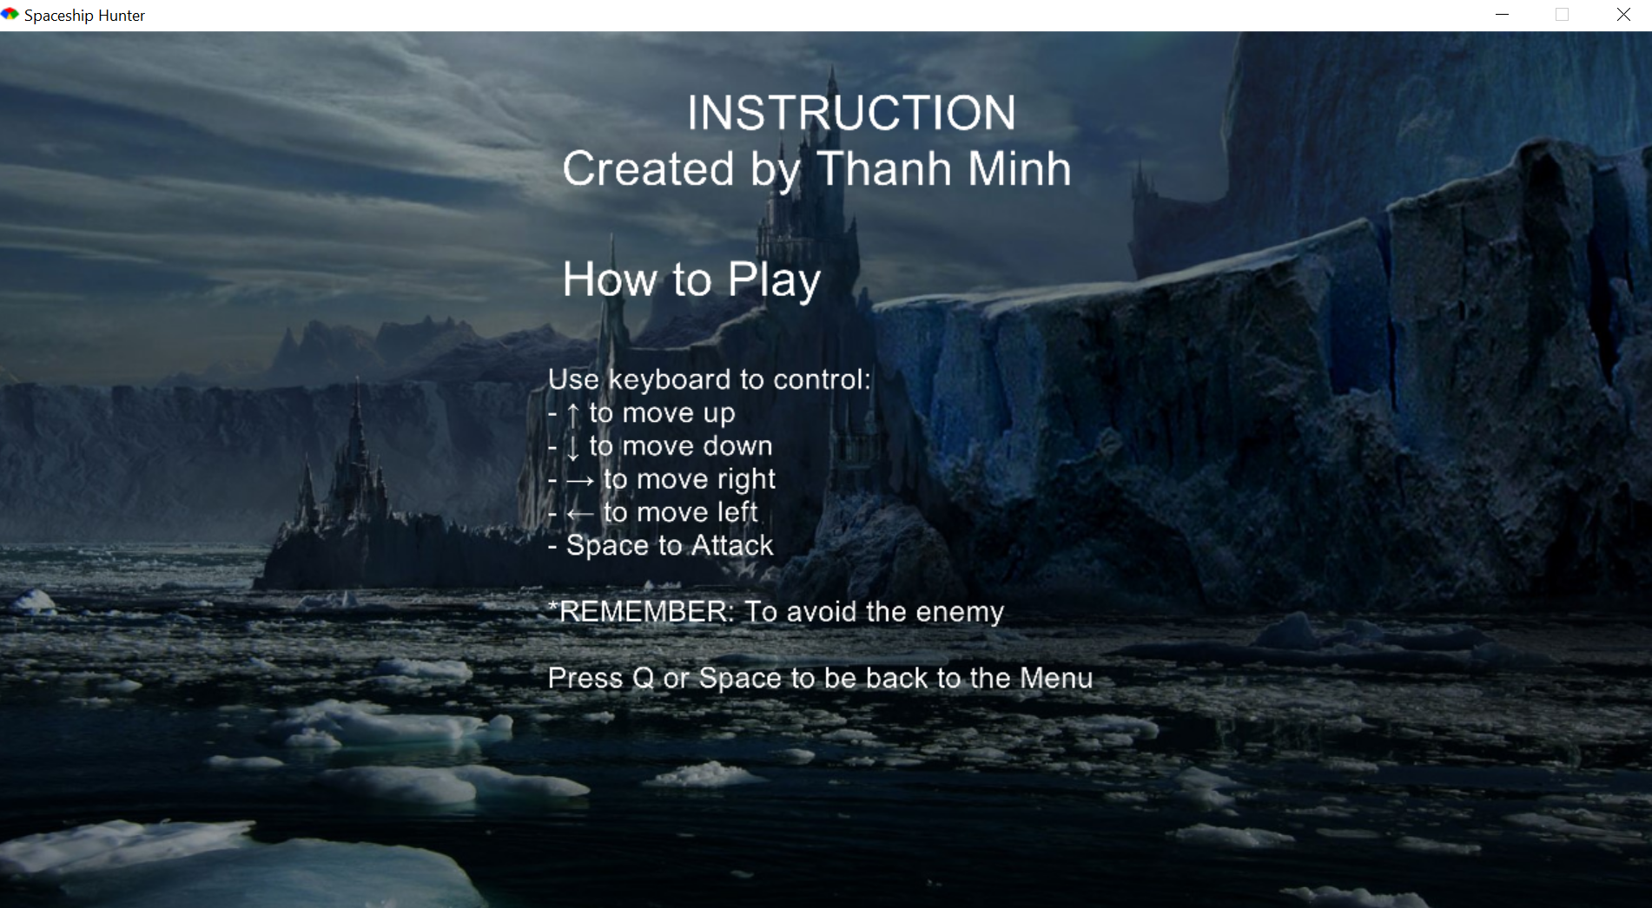

Figure 2: Instruction page

For this page, the user will know how to play and interact with the ship by using keyboard

1. **Selecting page**

Figure 3: Selecting Player page

Before going into the game further, the user need to choose a ship which will be the player to shoot the enemy down.

1. **Playing page**

Figure 4: Playing page for first player

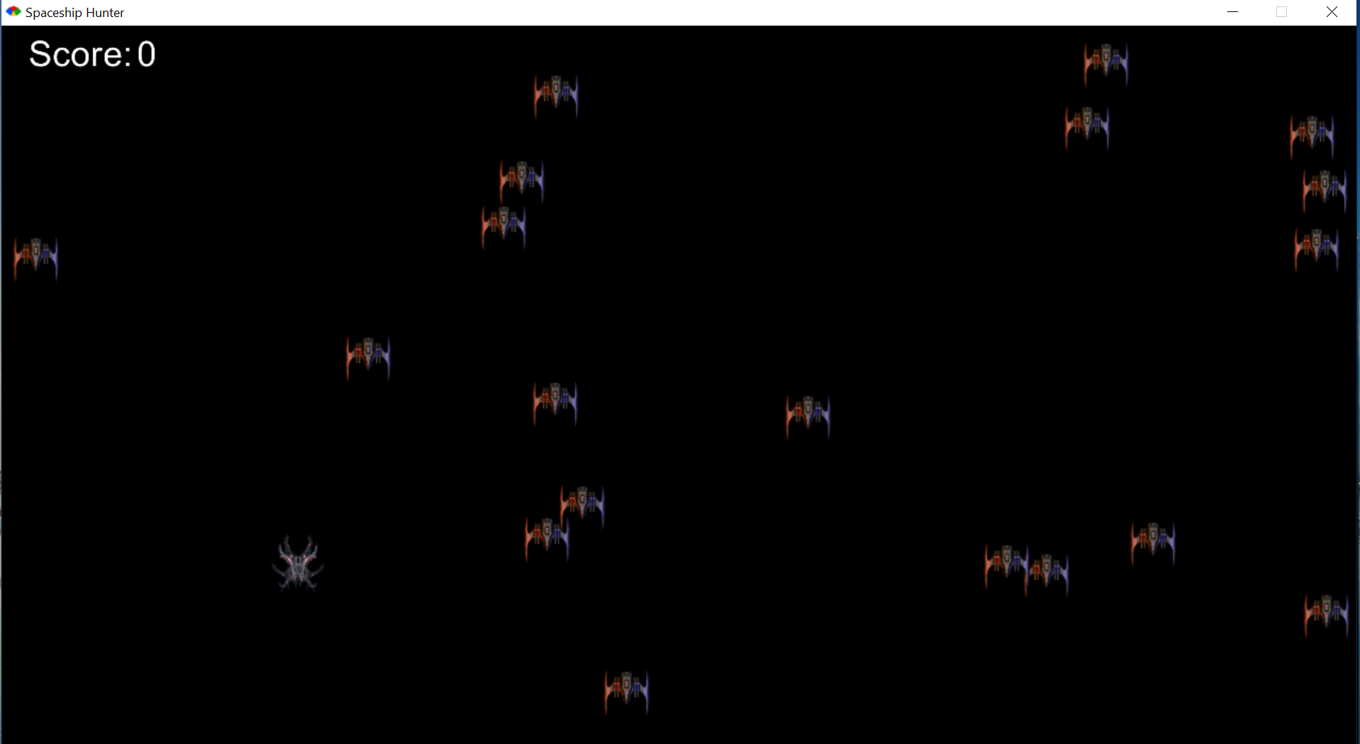

Figure 5: Playing page for the second player

Every time the player shoots down an opponent, the score will be increase by one and when the player is dead due to get hit by the opponent or press the escape button, they will go straight to the next page which is the credit page.

1. **Credit page**

Figure 6: Credit page when pressing escape

Figure 7: Credit page when play get hit by enemy

The credit’s description is looped so it keeps showing the content which will make the program more attractive. If the player wants to play again, they can follow the instruction to be directed to the page they want